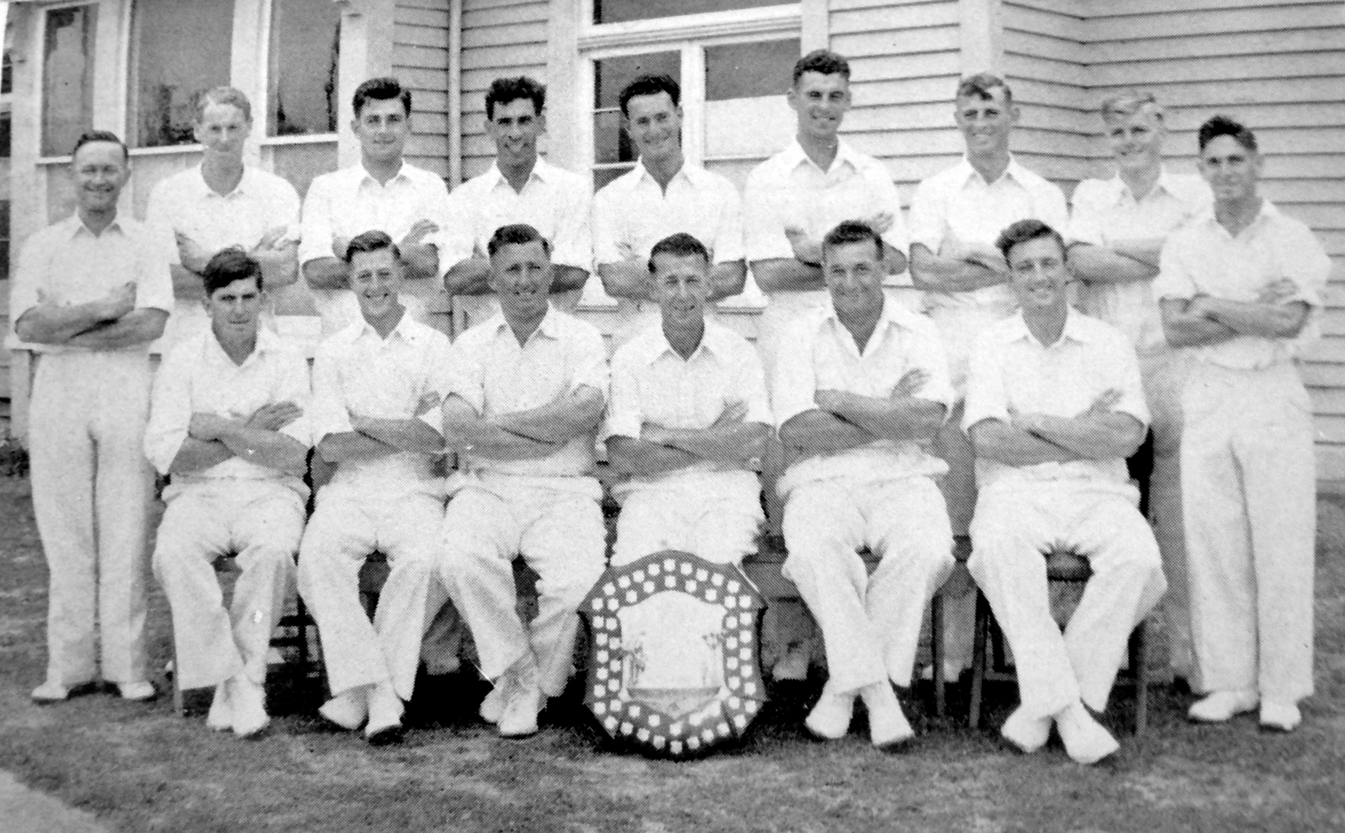

**Canterbury Representative Team 1955-56 Winners of the Plunket Shield**

**Back row:** SM Cameron, GC Coull, HN Dellow, SC Guillen, W Bell, BMJ Dineen, I McK Sinclair, JW D’Arcy, BA Haworth

**Front row:** GT Wright, BA Bolton, ME Chapple, RT Dowker (captain), GN Gearry, MW Jack